A000-Afr-Ghana-Tchamba-Mask-Wood-19th c

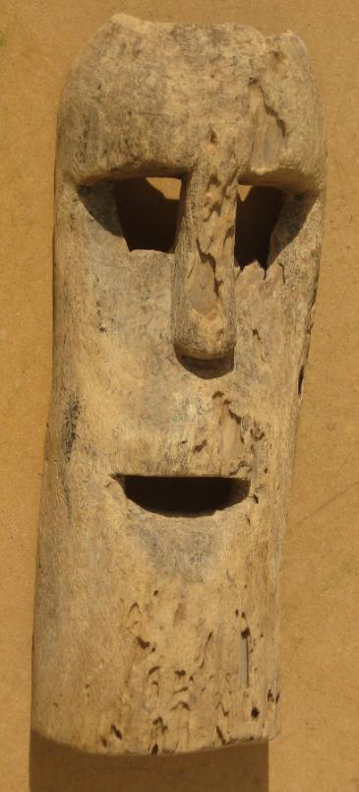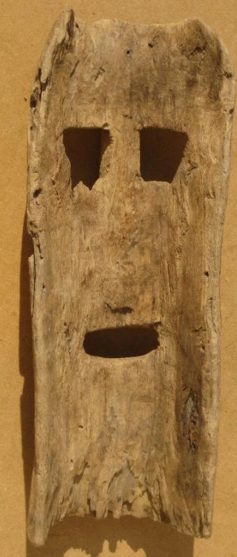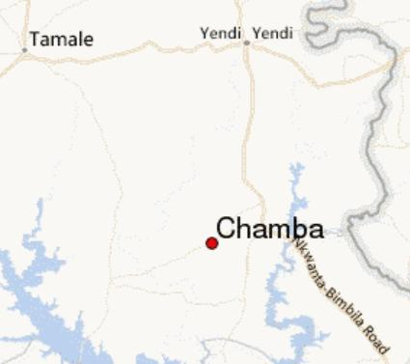

A nineteenth-century, intact wooden mask from the Tchamba indigenous people of northern Ghana whose area was once as large as the Protectorate of the Northern Territories of the British colony of the Gold Coast at the beginning of the 20th Century. This mask was collected in Chamba, their remaining tribal village in northern Ghana. Due to the Dagomba tribal wars between the [Dagomba people](https://en.wikipedia.org/wiki/Dagomba_people) and the [Kokomba people](https://en.wikipedia.org/w/index.php?title=Kokomba_people&action=edit&redlink=1) in the aftermath of the [First World War](https://en.wikipedia.org/wiki/First_World_War), many Tchamba fled south to [Accra](https://en.wikipedia.org/wiki/Accra), and still others founded Tchamba in Northern Togo.

Light-to-medium density wood, with superficial insect damage. Two drill holes (one field repaired) on either side for raffia decoration or hold-strap.

14 inches tall by 5.4 inches wide. 1.1 lbs.